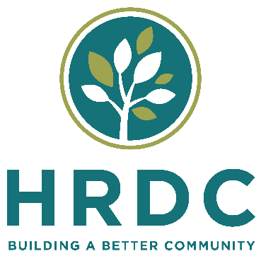
Request for Proposals
HRDC is seeking an electric forklift.
Proposals will be received until 5 pm on Feb. 24th. Please address or email (preferred) to:
HRDC – Gallatin Valley Food Bank
602 Bond Street
Bozeman, MT 59715
Attn: Jon Horn, Operations Manager Gallatin Valley Food Bank
jhorn@thehrdc.org
406-586-7600
Any questions about the specifications or bid process may be addressed to Jon Horn.
About HRDC
HRDC is a 501(c)3 non-profit Community Action Agency incorporated in 1975. HRDC is dedicated to building a better community through innovation and leadership. We provide programs and services in the areas of Housing, Food & Nutrition, Child & Youth Development, Senior Empowerment, Community Transportation, Home Heating–Energy–Safety, and Community Development. HRDC’s main office is located in Bozeman, Montana and provides services to three counties – Gallatin, Park and Meagher counties. HRDC has a 15 member volunteer board of directors and approximately 200 employees.
Description of the project:
HRDC is addressing the need for additional space and services within three of our seven service areas. This Fork lift will address the need for additional and more functional space for our Gallatin Valley Food Bank, a key component in our Food and Nutrition Department. Due to increasing demand on existing services, our Gallatin Valley Food Bank will no longer sustain the growth the valley is experiencing. Our new space called Market Place will require a forklift that raises 200 inches.
HRDC needs/schedule:
The purpose of this Request for Proposal is to obtain a forklift meeting the following requirements:
- Sit Down Rider Electric Forklift, 36V or 48V battery
- Load capacity: 3,500 lbs
- Maximum lift height: 200” +
- Turning radius: able to turn with a load in a 12 ft. aisle
- Side shift-equipped
- Freezer package if available
- Lowered Mast height and over all forklift height: needs to clear less than 96”
- Inside/Outside capable tires
- Power for the charging station will be 208Y/120V 3-phase
- If battery and charger are sold separately from the forklift, please provide quotes for those as well

Schedule:
Feb. 6, 2023 RFP issued.
Feb. 24, 2023 Proposals due by close of business
Feb. 28, 2023 Interviewees selected and notified via phone; other firms notified of decision by letter.
Track Record and References:
- Please provide a client list
- Delivery of product by date requested
HRDC RFP Firm Scoring Sheet
Factors | Point Range | CEO | Brd Rep | Assoc  Dir | Program Director | Ops. Manager
1. Dealers Capabilities
a. Prior customer feedback | 0-10
b.. Ability to service the forklift | 0-10
c. Warranty | 0-10
d. Ability to deliver product by September 2023 | 0- 20
5. Price | 0-50
MAXIMUM POINTS | 100

HRDC reserves the right to reject any bids.
HRDC instills hope, develops resources, designs solutions and changes lives. We envision a place where poverty has no impact because opportunities and quality of life are equally afforded to everyone.

