250Monday | Tuesday | Wednesday | Thursday | Friday
Fruit and Grain Bar  String Cheese  Apple Sauce Cups  Milk | Granola  Yogurt  Banana  Milk | Muffin  String Cheese  Orange Slices  Milk | Bagel  Cream Cheese  Fruit Juice  Milk | Breakfast Bar  Hard Boiled Egg  Apple Slices  Milk
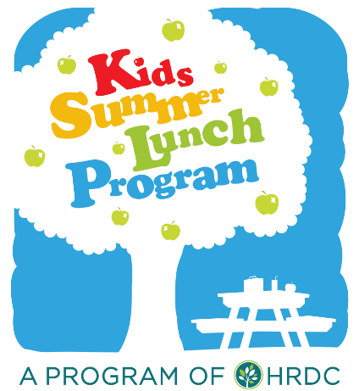
Summer Breakfast Program Menu 2018

Breakfast menu is subject to change due to pricing and availability.
It will always incorporate a protein, grain, fruit, and 1 % milk.

In accordance with federal law and U.S. Department of Agriculture policy, this institution is prohibited from discriminating on the basis of race, color, national origin, sex, age, or disability. To file a complaint of discrimination, write USDA, Director, Office of Civil Rights, 1400 Independence Avenue, SW, Washington, DC 20250-9410 or call (800) 795-3272 (voice) or (202) 720-6382 (TTY). USDA is an equal opportunity provider and employer.

To learn more about Summer Lunch or our other programs visit GALLATINVALLEYFOODBANK.ORG or
call us at 406-586-7600.

